Name – Vatsalya Jain
Roll No.- 67
C Programing Assingnment 1
- Arithmetic Operators + - * / %
// 1. Write a C program to input two numbers and print their sum, difference, product, quotient, and remainder.
# include <stdio.h>
int main(){
int a, b;
printf("Enter A and B: ");
scanf("%d %d", &a, &b);

printf("\nSum is: %d", a+b);
printf("\nSub is: %d", a-b);
printf("\nMulti is: %d", a*b);
printf("\nDiv is: %d", a/b);
return 0;
}
Output :
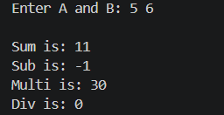

//2. Write a program to calculate the area and perimeter of a rectangle.
# include <stdio.h>
int main(){
int len, bre;
printf("Enter Length: ");
scanf("%d",&len);
printf("Enter Breadth: ");
scanf("%d",&bre);
printf("\n Area is: %d", len*bre );
printf("\n Parameter is: %d", 2*(len+bre) );

return 0;
}

OUTPUT:
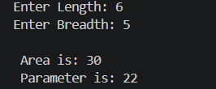

// 3. Write a program to calculate the simple interest using arithmetic operators.
int main(){
float P,R,T;
printf("Enter Principle: ");
scanf("%f",&P);
printf("Enter Rate: ");
scanf("%f",&R);
printf("Enter Time: ");
scanf("%f",&T);

float SI = (P*R*T)/100;
printf("\n SImple Intrest is: %.2f", SI );

return 0;
}
OUTPUT:
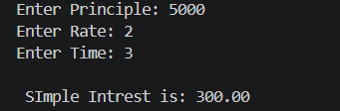

// 4. Write a program to input a 3-digit number and find the sum of its digits.
# include <stdio.h>
int main(){
int a,b,c,n;
printf("Enter Number: ");
scanf("%d",&n);

a = n%10;
n = n/10;
b = n%10;
n = n/10;
c = n%10;
n = n/10;
int sum = a+b+c;
printf("\n Sum of 3 digit number is : %d", sum );

return 0;
}
OUTPUT:
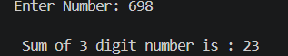

// 5. Write a program to convert seconds into hours, minutes, and seconds.
# include <stdio.h>
int main(){
int hours, sec, min, cal;
printf("Enter Number: ");
scanf("%d",&sec);

hours = sec/3600;
sec = sec%3600;

min = sec/60;
sec = sec%60;

printf("\n Hours: %d", hours );
printf("\n Minutes: %d", min );
printf("\n Seconds: %d", sec );

return 0;
}
OUTPUT:
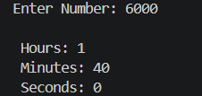
- Relational Operators <>, <=,>=, == & !=
// 1. Write a program to input two numbers and check which number is greater.
# include <stdio.h>
int main() {
int num1, num2;
printf("Enter two numbers: ");
scanf("%d %d", &num1, &num2);

if (num1 > num2) {
printf("%d is greater than %d\n", num1, num2);
} else if (num2 > num1) {
printf("%d is greater than %d\n", num2, num1);
} else {
printf("Both numbers are equal.\n");
}

return 0;
}
OUTPUT:
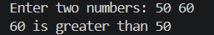

// 2. Write a program to check whether a number is equal to zero, positive, or negative.
# include <stdio.h>
int main() {
int num1, num2;
printf("Enter a numbers: ");
scanf("%d", &num1);

if (num1 > 0) {
printf("%d is a positive number.\n", num1);
} else if (num1 < 0) {
printf("%d is not a positive number.\n", num1);
} else {
printf("%d is zero.\n", num1);
}

return 0;
}
OUTPUT:
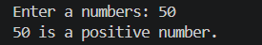
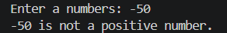

// 3. Write a program to input a student&#39;s marks and check whether the student has passed or failed.
#include <stdio.h>

int main() {
int marks;
printf("Enter the student's marks: ");
scanf("%d", &marks);

if (marks >= 40) {
printf("The student has passed.\n");
} else {
printf("The student has failed.\n");
}

return 0;
}
OUTPUT:
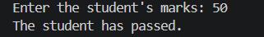

//4. Write a program to find the largest of two numbers using relational operators.
# include <stdio.h>
int main() {
int num1, num2;
printf("Enter two numbers: ");
scanf("%d %d", &num1, &num2);

if (num1 > num2) {
printf("%d is greater than %d\n", num1, num2);
} else if (num2 > num1) {
printf("%d is greater than %d\n", num2, num1);
} else {
printf("Both numbers are equal.\n");
}

return 0;
}
OUTPUT:
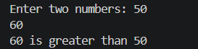
//5. Write a program to check whether a given year is a leap year.
#include <stdio.h>

int main() {
int year;
printf("Enter a year: ");
scanf("%d", &year);

if ((year % 4 == 0 && year % 100 != 0) || (year % 400 == 0)) {
printf("%d is a leap year.\n", year);
} else {
printf("%d is not a leap year.\n", year);
}

return 0;
}
OUTPUT:
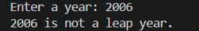

- Logical Operators &&,||, !

//1. Write a program to check whether a number lies between 10 and 50.
#include <stdio.h>
int main() {
int num;
printf("Enter a number: ");
scanf("%d", &num);
if (num > 10 && num < 50) {
printf("%d lies between 10 and 50.\n", num);
} else {
printf("%d does not lie between 10 and 50.\n", num);
}
return 0;
}
OUTPUT:
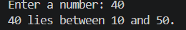

//2. Write a program to check whether a person is eligible to vote based on age.
#include <stdio.h>
int main() {
int age;
printf("Enter your age: ");
scanf("%d", &age);
if (age >= 18) {
printf("You are eligible to vote.\n");
} else {
printf("You are not eligible to vote.\n");
}
return 0;
}
OUTPUT:
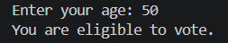

//3. Write a program to check whether a number is divisible by both 3 and 5.
#include <stdio.h>
int main() {
int num;
printf("Enter a number: ");
scanf("%d", &num);
if (num % 3 == 0 && num % 5 == 0) {
printf("%d is divisible by both 3 and 5.\n", num);
} else {
printf("%d is not divisible by both 3 and 5.\n", num);
}
return 0;
}
OUTPUT:
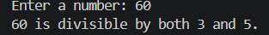

//4. Write a program to check whether a number is positive and even.
#include <stdio.h>
int main() {
int num;
printf("Enter a number: ");
scanf("%d", &num);
if (num > 0 ) {
if (num % 2 == 0) {
printf("%d is a positive and even number.\n", num);
} else {
printf("%d is a positive but not an even number.\n", num);
}
} else {
printf("%d is not a positive number.\n", num);
}
return 0;
}
OUTPUT:
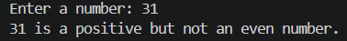

//5. Write a program to check whether a character is a vowel or consonant using logical operators.
#include <stdio.h>
int main() {
char ch;
printf("Enter a character: ");
scanf(" %c", &ch);
if ((ch == 'a' || ch == 'e' || ch == 'i' || ch == 'o' || ch == 'u') ||
(ch == 'A' || ch == 'E' || ch == 'I' || ch == 'O' || ch == 'U')) {
printf("%c is a vowel.\n", ch);
} else {
printf("%c is a consonant.\n", ch);
}
return 0;
}
OUTPUT:
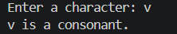
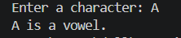

- Assignment Operators = += -= *= /= %=

//1. Write a program to demonstrate all compound assignment operators.
#include <stdio.h>
int main() {
int a, b;
printf("Enter two numbers: ");
scanf("%d %d", &a, &b);

printf("\nInitial values: a = %d, b = %d\n", a, b);

a += b; // Addition assignment
printf("After a += b: a = %d\n", a);

a -= b; // Subtraction assignment
printf("After a -= b: a = %d\n", a);

a *= b; // Multiplication assignment
printf("After a *= b: a = %d\n", a);

if (b != 0) {
a /= b; // Division assignment
printf("After a /= b: a = %d\n", a);
} else {
printf("Division by zero is not allowed.\n");
}

if (b != 0) {
a %= b; // Modulus assignment
printf("After a %%= b: a = %d\n", a);
} else {
printf("Modulus by zero is not allowed.\n");
}
return 0;
}
OUTPUT:
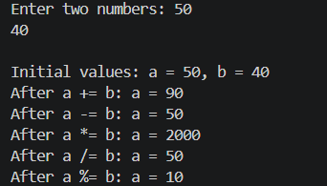

//2. Write a program that increases a number by 10 using +=.
#include <stdio.h>
int main() {
int num;
printf("Enter a number: ");
scanf("%d", &num);
num += 10;
printf("The number after increasing by 10 is: %d\n", num);
return 0;
}
OUTPUT:
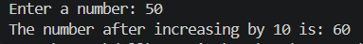

//3. Write a program that decreases a number by 5 using -=.
#include <stdio.h>
int main() {
int num;
printf("Enter a number: ");
scanf("%d", &num);
num -= 5;
printf("The number after increasing by 10 is: %d\n", num);
return 0;
}
OUTPUT:
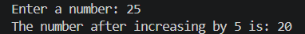

//4. Write a program to calculate the final value of a variable after applying +=, -=, *=, and /=.
# include<stdio.h>
int main(){
int num;
printf("Enter a number: ");
scanf("%d", &num);
num += 10; // Increase by 10
printf("After += 10: %d\n", num);
num -= 5; // Decrease by 5
printf("After -= 5: %d\n", num);
num *= 2; // Multiply by 2
printf("After *= 2: %d\n", num);
if (num != 0) {
num /= 3; // Divide by 3
printf("After /= 3: %d\n", num);
} else {
printf("Division by zero is not allowed.\n");
}
return 0;
}
OUTPUT:
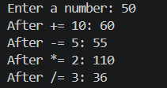

- Bitwise Operators.

//1. Write a C program to find the result of bitwise AND of two numbers.
# include <stdio.h>
int main() {
int num1, num2;
printf("Enter two numbers: ");
scanf("%d %d", &num1, &num2);

int result = num1 & num2;
printf("The result of bitwise AND of %d and %d is: %d\n", num1, num2, result);

return 0;
}
OUTPUT:
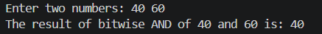

//2. Write a program to demonstrate AND, OR, and XOR operators.
#include <stdio.h>
int main() {
int num1, num2;
printf("Enter two numbers: ");
scanf("%d %d", &num1, &num2);

int and_result = num1 & num2;
int or_result = num1 | num2;
int xor_result = num1 ^ num2;

printf("The result of bitwise AND of %d and %d is: %d\n", num1, num2, and_result);
printf("The result of bitwise OR of %d and %d is: %d\n", num1, num2, or_result);
printf("The result of bitwise XOR of %d and %d is: %d\n", num1, num2, xor_result);

return 0;
}
OUTPUT:
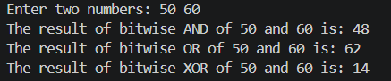

//3. Write a program to check whether a number is even or odd using bitwise AND.
#include <stdio.h>
int main() {
int num;
printf("Enter a number: ");
scanf("%d", &num);

if (num & 1) {
printf("%d is an odd number.\n", num);
} else {
printf("%d is an even number.\n", num);
}

return 0;
}
OUTPUT:
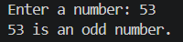
//4. Write a program to multiply a number by 2 using the left shift operator.
#include <stdio.h>
int main() {
int num;
printf("Enter a number: ");
scanf("%d", &num);

int result = num << 1;

printf("The result of multiplying %d by 2 using left shift is: %d\n", num, result);

return 0;
}
OUTPUT:
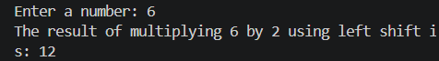

//5. Write a program to divide a number by 2 using the right shift operator.
#include <stdio.h>
int main() {
int num;
printf("Enter a number: ");
scanf("%d", &num);

int result = num >> 1;

printf("The result of dividing %d by 2 using right shift is: %d\n", num, result);

return 0;
}
OUTPUT:
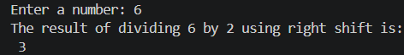

- Conditional Operator.
//1. Write a program to find the largest of two numbers using the conditional operator.
#include<stdio.h>
int main(){
int a,b;
printf("Enter A and B: ");
scanf("%d %d", &a, &b);

(a>b)? printf("\n A is largest: %d", a): printf("\n B is largest: %d", b);
return 0;
}

OUTPUT:
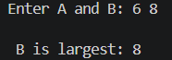

//2. Write a program to check whether a number is even or odd using ?:.
# include<stdio.h>
int main(){
int n;
printf("Enter Number: ");
scanf("%d", &n);

(n%2==0)? printf("\n Your Number is Even: %d", n ): printf("\n Your Number is Odd: %d", n );

return 0;
}
OUTPUT:
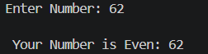

//3. Write a program to find the smallest of two numbers using ?:.
# include <stdio.h>
int main(){
int a,b;
printf("Enter A and B: ");
scanf("%d %d", &a, &b);

(a<b)? printf("\n A is smallest: %d", a ): printf("\n B is smallest: %d", b );

return 0;
}
OUTPUT:
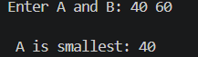

// 4. Write a program to check whether a person is eligible or not eligible to vote using ?:.
# include <stdio.h>
int main(){
int age;
printf("Enter Age: ");
scanf("%d",&age);

(age>=18)? printf("\n You are Eligible for Voting: %d", age ): printf("\n You are Not Eligible for Voting: %d", age );

return 0;
}
OUTPUT:
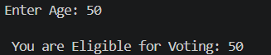

//5. Write a program to find the largest of three numbers using nested conditional operators.in ternory opretors
# include<stdio.h>
int main(){
int a,b,c;
printf("Enter A, B and C: ");
scanf("%d %d %d", &a, &b, &c);

(a>b)? (a>c? printf("\n A is largest: %d", a): printf("\n C is largest: %d", c)): (b>c? printf("\n B is largest: %d", b): printf("\n C is largest: %d", c));

return 0;
}
OUTPUT:
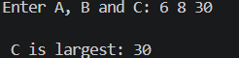

- Increment and Decrement++ --

//1. Write a program to demonstrate pre-increment and post-increment.
#include <stdio.h>
int main() {
int num;
printf("Enter a number: ");
scanf("%d", &num);

int pre_increment = ++num;
int post_increment = num++;

printf("After pre-increment, the value is: %d\n", pre_increment);
printf("After post-increment, the value is: %d\n", post_increment);
printf("The final value of num is: %d\n", num);

return 0;
}
OUTPUT:
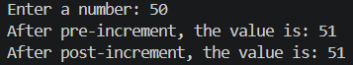
//2. Write a program to demonstrate pre-decrement and post-decrement.
#include <stdio.h>
int main() {
int num;
printf("Enter a number: ");
scanf("%d", &num);

int pre_decrement = --num;
int post_decrement = num--;

printf("After pre-decrement, the value is: %d\n", pre_decrement);
printf("After post-decrement, the value is: %d\n", post_decrement);
printf("The final value of num is: %d\n", num);

return 0;
}
OUTPUT:
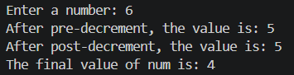

- Special Operators

//1. Important special operators in C include sizeof, comma.
#include <stdio.h>
int main() {
int num;
printf("Enter a number: ");
scanf("%d", &num);

printf("The size of the number is: %zu bytes", sizeof(num));

return 0;
}
OUTPUT:
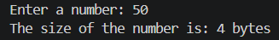

//2. Write a program to find the size of int, float, char, and double using sizeof.
#include <stdio.h>
int main() {
int num;
float fnum;
char ch;
double dnum;
printf("Enter a number: ");
scanf("%d", &num);
printf("Enter a float number: ");
scanf("%f", &fnum);
printf("Enter a character: ");
scanf(" %c", &ch);
printf("Enter a double number: ");
scanf("%lf", &dnum);

printf("The size of int is: %zu bytes\n", sizeof(num));
printf("The size of float is: %zu bytes\n", sizeof(fnum));
printf("The size of char is: %zu bytes\n", sizeof(ch));
printf("The size of double is: %zu bytes\n", sizeof(dnum));

return 0;
}
OUTPUT:
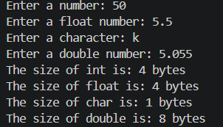

//3. Write a program to use the comma operator and find the final value of a variable.
#include <stdio.h>
int main() {
int num = 10;
num = (num += 5, num *= 2, num - 3);

printf("The final value of num is: %d\n", num);

return 0;
}
OUTPUT:

- OUTPUTS

OUTPUT 1 IS:
OUTPUT 2 IS:
OUTPUT 3 IS:
OUTPUT 4 IS:
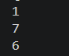
OUTPUT 5 IS:
OUTPUT 6 IS:
OUTPUT 7 IS:
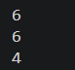
OUTPUT 8 IS:
OUTPUT 9 IS:
